EXPLORATORY DATA ANALYSIS REPORT
Fitness Market Analysis
LA Fitness Expansion Strategy Across Florida Counties
All 67 Florida counties | Census + Google Places | OLS regression
Prepared for the MSIS Data Science Assignment | August 29, 2026

Observed demographic and location data; transparently estimated membership-price target

Purpose and Scope
This report examines the market structure of all 67 Florida counties before regression modeling. It combines official demographic measures with live Google Places results for LA Fitness and four competitor brands. The objective is to identify distributions, relationships, and unusual counties that may affect model interpretation or expansion decisions.
Critical limitation: MembershipPrice is an estimated teaching variable, not an observed county price survey. It is generated from documented market inputs and random noise (seed 6643). EDA findings involving price demonstrate the workflow and must not be treated as independent market evidence.

Data Collection and Preparation

Observed demographic inputs
- CountyPopulation: 2020 Census PL 94-171 total population (P1_001N).
- MedianHouseholdIncome: 2021 ACS five-year estimate (B19013_001E).
- LandAreaSqMiles: 2020 Census Gazetteer; PopulationDensity is population divided by land area.

Observed gym-market inputs
The Google Places Text Search pipeline issued branded, county-specific queries, filtered results to exact county and brand matches, and deduplicated by Place ID. It retained 387 locations across the five tracked brands.
Tracked brand | Accepted locations
Planet Fitness | 176
Orangetheory Fitness | 107
LA Fitness | 88
Gold's Gym | 11
24 Hour Fitness | 5

Google Places results are a retrieval-time snapshot. Search relevance, closures, brand naming, and data coverage can change, so counts should be validated before a real estate commitment.

Missing-Data Treatment
- Missing LA Fitness and competitor counts were set to zero after the county merge.
- 23 counties with no retained tracked-brand ratings received the statewide median Google Places rating. The completed MainDataset contains no missing values.
- Post-integration missing values in the analytical dataset: 0.

Descriptive Statistics
Variable | Mean | Median | Std. dev. | Minimum | Maximum
MembershipPrice | $37.98 | $37.45 | $3.52 | $31.58 | $46.46
CountyPopulation | 321,465.48 | 129,752.00 | 500,924.43 | 7,974.00 | 2,701,767.00
LAFitnessLocations | 1.31 | 0.00 | 3.18 | 0.00 | 16.00
CompetitorLocations | 4.46 | 2.00 | 6.78 | 0.00 | 29.00
MedianHouseholdIncome | $56,361 | $56,786 | $11,801 | $38,088 | $88,794
PopulationDensity | 384.49 | 188.16 | 574.10 | 9.54 | 3,504.16
AvgGymRating | 4.42 | 4.40 | 0.14 | 4.10 | 4.80

Required Visual Analysis
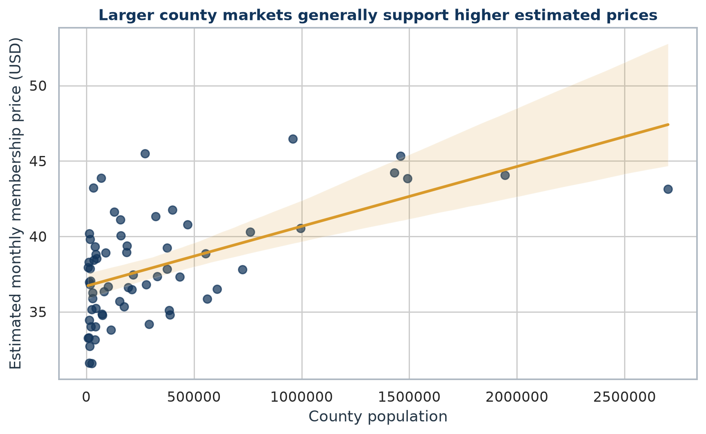
Figure 1. County population versus estimated monthly membership price.
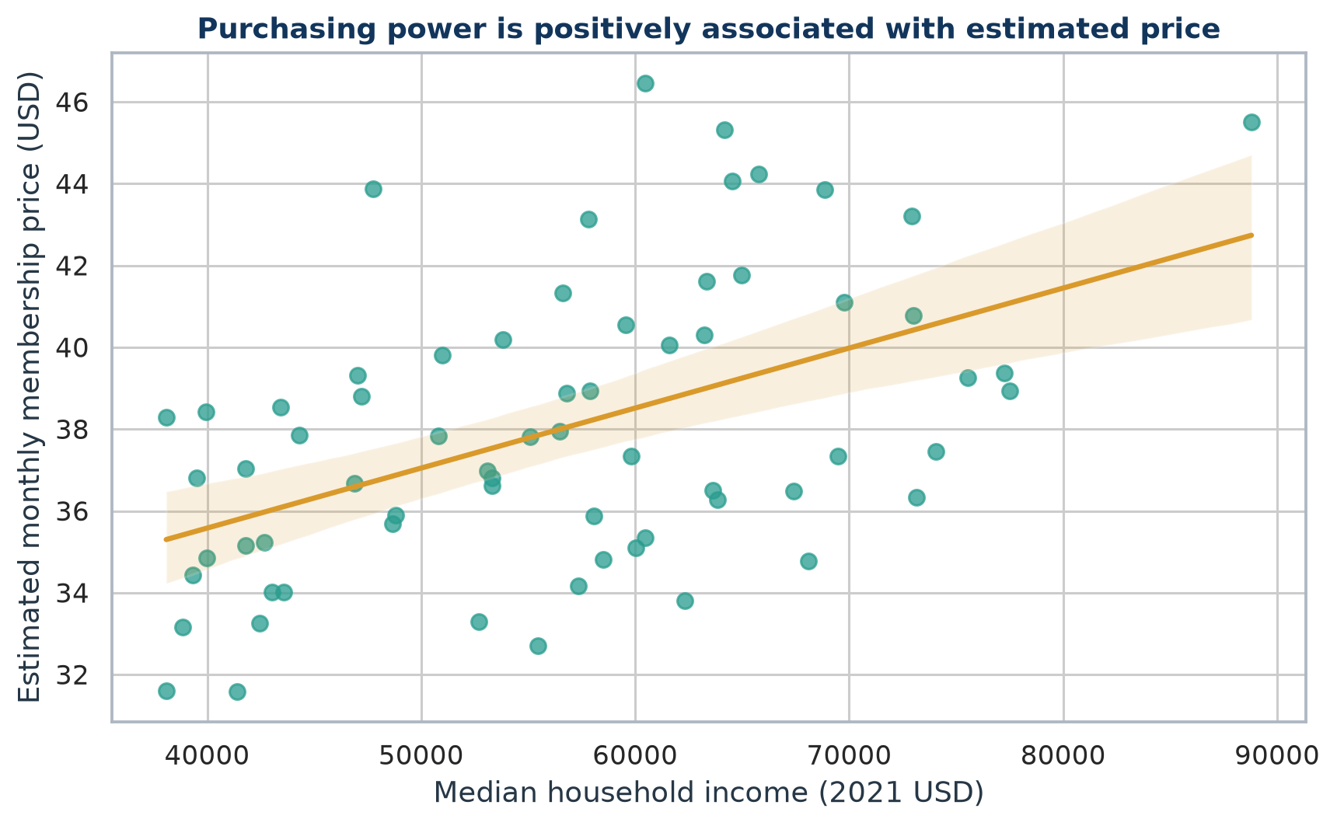
Figure 2. Median household income versus estimated monthly membership price.
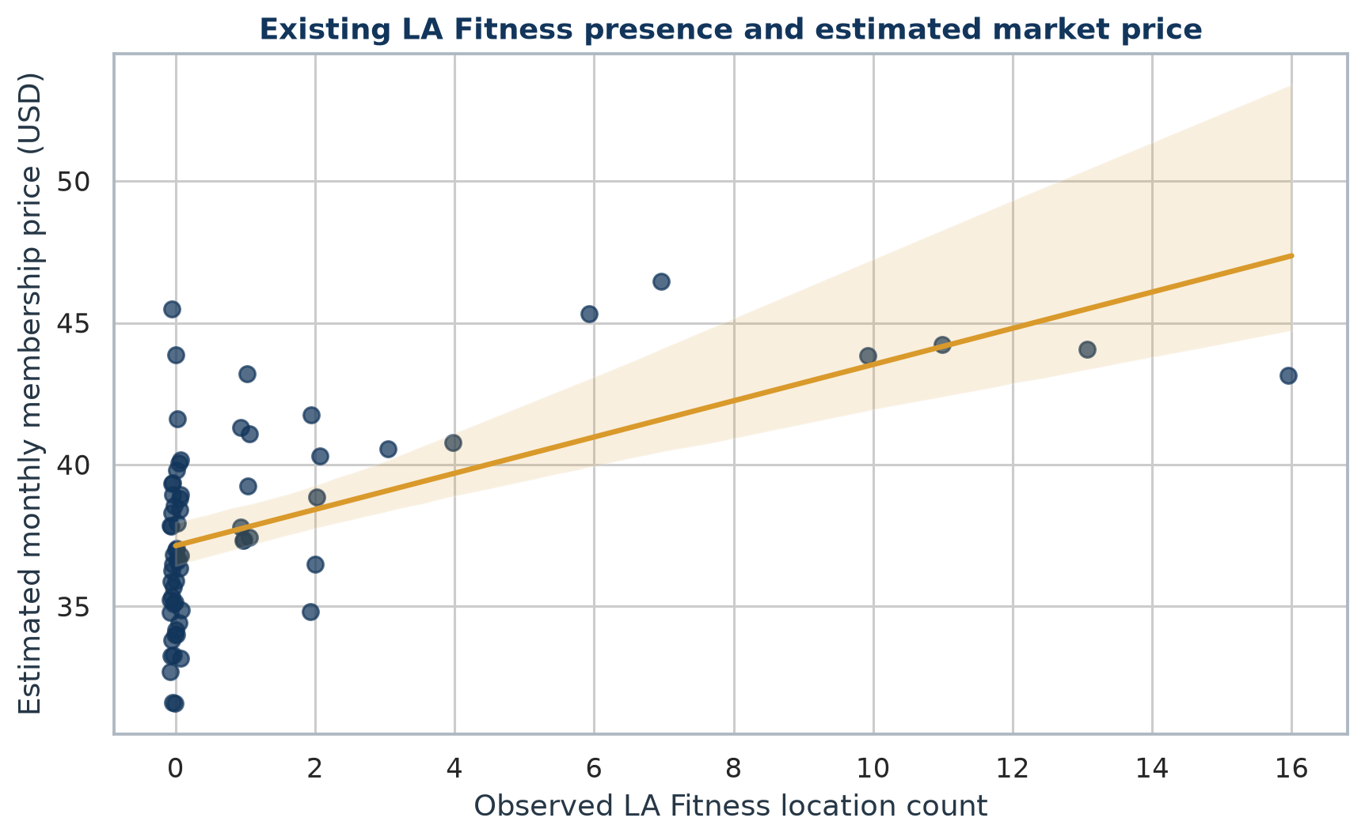
Figure 3. Observed LA Fitness location count versus estimated price.
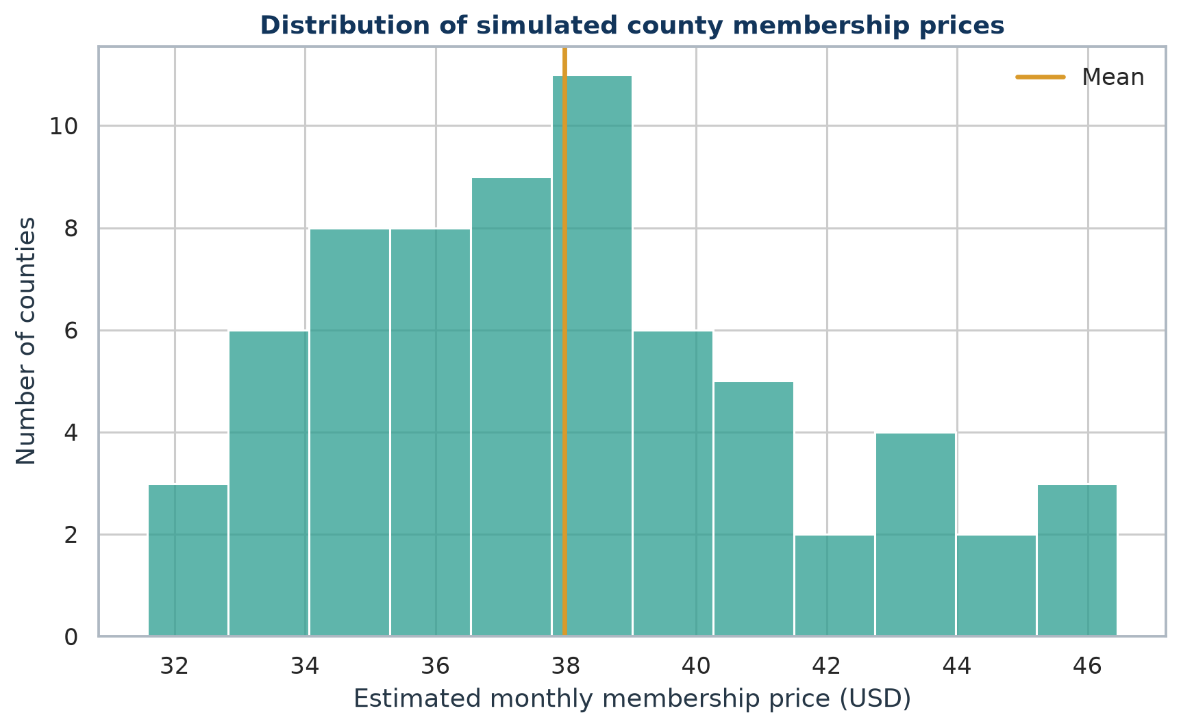
Figure 4. Distribution of estimated county membership prices.
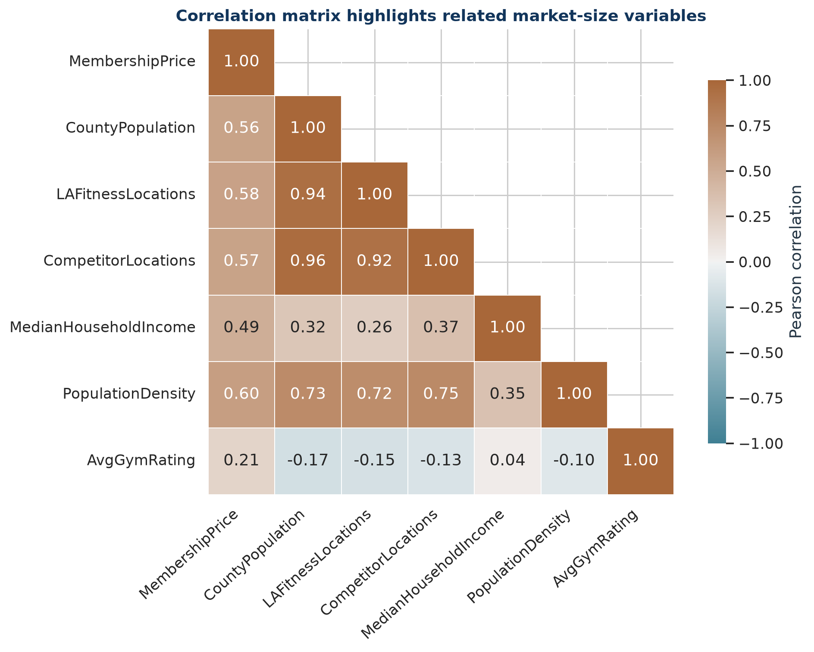
Figure 5. Pearson correlation matrix for all analytical variables.

Correlation Findings
- PopulationDensity: r = 0.598 (positive).
- LAFitnessLocations: r = 0.577 (positive).
- CompetitorLocations: r = 0.570 (positive).
- CountyPopulation: r = 0.563 (positive).
- MedianHouseholdIncome: r = 0.491 (positive).
- AvgGymRating: r = 0.211 (positive).
The market-size variables are also related to one another. This is expected because large, dense, affluent counties tend to support more fitness locations. Those relationships motivate the formal VIF check in the regression report.

Outliers and Business Meaning
- Population: Miami-Dade County is the largest county market at 2,701,767 residents, giving it disproportionate leverage in raw population relationships.
- Density: Pinellas County has the highest density at 3,504.2 residents per square mile, reflecting a different site-selection environment from geographically large rural counties.
- Purchasing power: St. Johns County has the highest 2021 median household income at $88,794.
- Influence diagnostics flagged Pinellas County, Miami-Dade County, St. Johns County, Columbia County. These counties deserve sensitivity review; a flag does not mean the data are wrong.

EDA Conclusions
- County markets differ sharply in size, density, purchasing power, and chain presence.
- Estimated price is most strongly associated with a subset of the market variables, but the target is synthetic by design.
- The 67-row dataset is complete and suitable for the required OLS demonstration, subject to multicollinearity and influence checks.
- Business use requires observed county pricing, a refreshed Places pull, and direct validation of candidate trade areas.

References
U.S. Census Bureau. 2020 Census Redistricting Data, Table P1, variable P1_001N. Source
U.S. Census Bureau. 2021 ACS 5-Year Estimates, Table B19013, median household income. Source
U.S. Census Bureau. 2020 Gazetteer Files and record layout. Source
Google Maps Platform. Text Search (New) documentation and pagination requirements. Source
LA Fitness. Public online membership rate example with monthly plan options. Source
Planet Fitness. Official membership page with starting monthly rates. Source
Health & Fitness Association. U.S. facility membership and average-dues overview. Source

